**Bootstrap classes for styling tables**   
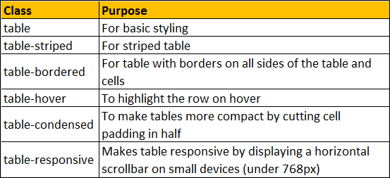  
  
**Contextual classes to color table rows or individual cells**   
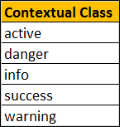  
  
Here is the HTML for the table without any boostrap table classes

<table>

    <thead>

        <tr>

            <th>Id</th>

            <th>Name</th>

            <th>Gender</th>

            <th>Email</th>

        </tr>

    </thead>

    <tbody>

        <tr>

            <td>1</td>

            <td>John</td>

            <td>Male</td>

            <td>John@emailDomain.com</td>

        </tr>

        <tr>

            <td>2</td>

            <td>Mary</td>

            <td>Femlae</td>

            <td>mary@emailDomain.com</td>

        </tr>

        <tr>

            <td>3</td>

            <td>Ben</td>

            <td>Male</td>

            <td>Ben@emailDomain.com</td>

        </tr>

        <tr>

            <td>4</td>

            <td>Sara</td>

            <td>Female</td>

            <td>sara@emailDomain.com</td>

        </tr>

        <tr>

            <td>5</td>

            <td>Sam</td>

            <td>Male</td>

            <td>sam@emailDomain.com</td>

        </tr>

    </tbody>

</table>

**Output :**   
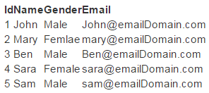  
  
**table class provides light padding and horizontal lines**

<table class="table">

    <!--rest of the HTML stays the same-->

</table>

**Output :**   
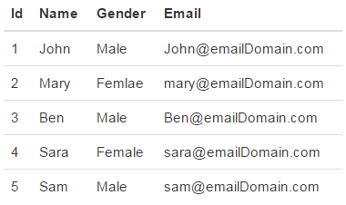  
  
**table-striped class provides zebra-striping for the table rows**

<table class="table table-striped">

    <!--rest of the HTML stays the same-->

</table>

**Output :**   
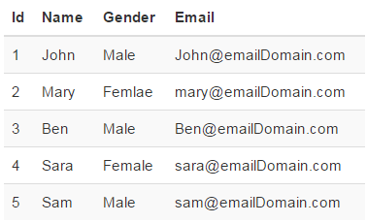  
  
**table-bordered class provide borders on all sides of the table and cells.**

<table class="table table-striped table-bordered">

    <!--rest of the HTML stays the same-->

</table>

**Output :**   
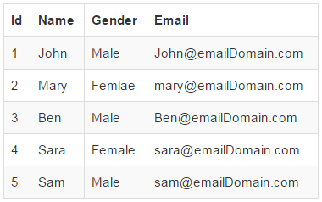  
  
**table-hover class provides highlighting of rows on hover**

<table class="table table-bordered table-hover">

    <!--rest of the HTML stays the same-->

</table>

**table-condensed class makes table more compact by cutting cell padding in half**

<table class="table table-bordered table-hover table-condensed">

    <!--rest of the HTML stays the same-->

</table>

**Output :**   
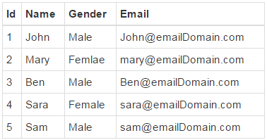  
  
**To make a table responsive**, place the table inside a <div> element, and apply table-responsive class on the <div> element. This will provide a horizontal scrollbar when the screen size is less than 768px (i.e on a small device). On a screen size larger than 768px you will not find any difference. Applying the table-responsive class directly on the table will not do anything useful.

<div class="table-responsive">

    <table class="table table-bordered table-hover">

        <!--rest of the HTML stays the same-->

    </table>

</div>

**Output :**   
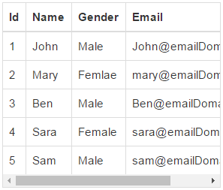  
  
**Use the bootstrap contextual classes to colour the table rows**

<div class="table-responsive">

    <table class="table table-bordered table-hover">

        <thead>

            <tr>

                <th>Id</th>

                <th>Name</th>

                <th>Gender</th>

                <th>Email</th>

            </tr>

        </thead>

        <tbody>

            <tr class="active">

                <td>1</td>

                <td>John</td>

                <td>Male</td>

                <td>John@emailDomain.com</td>

            </tr>

            <tr class="danger">

                <td>2</td>

                <td>Mary</td>

                <td>Femlae</td>

                <td>mary@emailDomain.com</td>

            </tr>

            <tr class="info">

                <td>3</td>

                <td>Ben</td>

                <td>Male</td>

                <td>Ben@emailDomain.com</td>

            </tr>

            <tr class="success">

                <td>4</td>

                <td>Sara</td>

                <td>Female</td>

                <td>sara@emailDomain.com</td>

            </tr>

            <tr class="warning">

                <td>5</td>

                <td>Sam</td>

                <td>Male</td>

                <td>sam@emailDomain.com</td>

            </tr>

        </tbody>

    </table>

</div>

**Output :**   
